Guitar Villains User Manual

Created by Fahad Aloufi, Shresth Mathur, Claire Qiao, Mike Carranza, Jakob Dieffenbach

This game is based off the popular game “Guitar Heroes” where notes will pass through a screen, and the player will attempt to hit that note on the correct beat.

This design takes four inputs via pushbuttons.

Pushbutton 1 [PB 1]: Note 1

Pushbutton 2 [PB 2]: Note 2

Pushbutton 3 [PB 3]: Mode Toggle

Pushbutton 4 [PB 4]: Quit – [In the EDIT mode, this button is treated as the toggle]

Our design is displayed via 14 LEDs, 2 colored LEDs, and 2 Seven Segment Displays (SSD).

The 14 LEDs are displayed into two rows of 7 which will display the note values.

Our game has six modes:

IDLE

EDIT

DIFFICULTY CONTROL

PLAY

PAUSE

FINISH/QUIT

Using **PB 3**, the player will be able to toggle between the 6 modes. At any point in the game, the player can press **PB 4**, to exit the game and go to the finish menu.

When the game is enabled, the player will start in **IDLE** mode. By toggling to the next mode, the player will be in the EDIT mode where they can edit the notes that will be displayed during the game.

**EDIT MODE:**

Using **PB 1**, **PB 2**, and **PB 4**, the player will edit the two 31 note songs. The first song the player can edit will be song **1** and using **PB 4**, the player will be able to toggle between **song 1** and **song 2.** The **green LED light** will light up for **song 1** and the **red LED light** will light up for **song 2**. **PB 2** signifies a note, while **PB 1** signifies a rest.

**DIFFICULTY CONTROL MODE:**

In this mode, the player will have the ability to adjust the difficulty of the game. There are three difficulty levels, **EASY, MEDIUM, HARD,** that the player may choose from. Each level corresponds to how fast the notes will move. In this mode, **PB 2** will be the toggle that will switch between the three difficulties. The current level will be displayed on the **SSD**s represented by **d1, d2, and d3.**

**PLAY MODE:**

When switching to this mode, the user will begin to play the game. The **TOP ROW** of LEDs will correspond to the first song, while the **BOTTOM ROW** of LEDs will correspond to the second song. Using **PB 1** will correspond to the first song, and **PB 2**, will correspond to the second song on the bottom row.

When playing, the **GREEN LED** will flash indicating a hit, the **RED LED** will flash indicating a miss, and **BOTH LEDs** will flash if one note was hit while the other was not hit.

By pressing **PB 3**, the game will **PAUSE** and by pressing **PB 3** again, it will resume the game from where the player originally left off.

During the game, the current score will be displayed on the two **SSD**. If the score is negative, the score will be flashing, otherwise the score will adjust as the game continues.

After all the notes have been played, the program will automatically move to the **FINISH MODE**.

**FINISH MODE:**

In the finish mode, **PB 1** will toggle throughout the four different score displays. After going to the **FINISH** mode, the current score will automatically be displayed. If the number is flashing, the score is negative, and the number of misses is greater than the hits.

By pressing **PB 1,** the highest score will be displayed, and a **RED & GREEN LED** light will be on. After toggling again, the amount of hits will be displayed with the **GREEN LED** being turned on. Finally, after toggling again, the number of misses will be displayed with the **RED LED** being turned on.

## Appendix – Project Overview Flow Chart

## Appendix 2 – Basic Wiring Diagram and Pin Layout

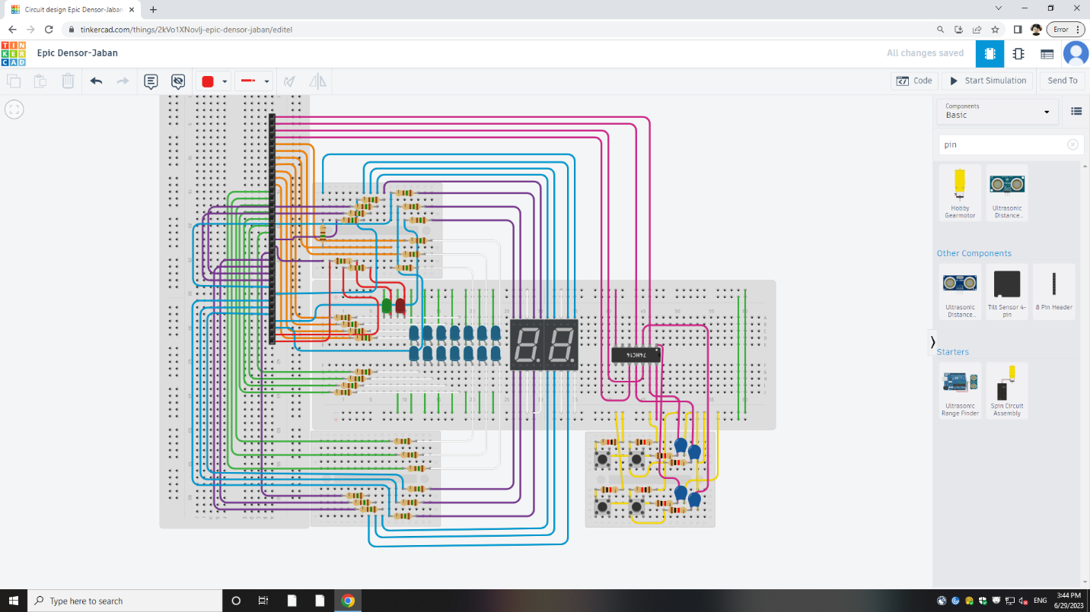

|  |  |
| --- | --- |
| GPIO Pins | Component Connection |
| GPIO[3:0] | Button 1 (GPIO[0])  Button 2 (GPIO[1])  Button 3 (GPIO[2])  Button 4 (GPIO[3]) |
| GPIO[10:4] | Top row of LEDs |
| GPIO[17:11] | Bottom row of LEDs |
| GPIO[24:18] | Seven Segment Display 1 |
| GPIO[31:25] | Seven Segment Display 2 |
| GPIO[32] | Red LED Display |
| GPIO[33] | Green LED Display |